Foundation Newsletter
Term 2, 2021
Welcome Back!
The students in Foundation have been able to easily resettle into the routines and expectations that they learned last term. They have been able to independently unpack their bags, change their take home books and have their planners ready to be signed by their teacher, which shows how organised and ready to learn they are. We encourage parents to continue to wave goodbye to their child at the door to help them continue to build on the school values of resilience and responsibility.

Arrival and Dismissal Times
Just a reminder that students should be at their classroom’s external door, ready to start their school day with their morning routine at 8:50am every morning. We encourage students to walk into the classroom, put their bag away, and begin their day at school independently. Students finish their day at 3:10pm and leave via the external classroom doors. Please make sure you do not pick up or drop off your child using the internal corridor to ensure consistency with all students. We thank you for your cooperation.

Communication with Teachers
Please be reminded that classroom teachers attend meetings after school each Tuesday, Wednesday and Thursday. We are available for a brief chat before school from 8:45 until learning time commences at 8:50, when students enter their classroom. Please feel free to contact your child’s teacher to arrange a meeting outside of these times as we are more than willing to discuss any issues or concerns. Teachers can be reached via email for non-urgent questions or concerns please use the link via the Compass App.

Take Home Reading and Homework
Take home reading has continued this term, and your child should be bringing home books daily. Please ensure your child is reading each day and returning their take home book every day with their home reading signed off in their student planner. Read with your child, to your child and have them read to you. Homework books will be sent home fortnightly and are expected back on Fridays – see homework sheets for correct dates. Homework is to be completed and recorded in the homework book prior to being returned.

Class Teddies
As part of our literacy program, we are introducing class teddies. The class teddy is a toy that each student will have the opportunity to be responsible for over 3 nights during the week, going home on a Monday and coming back to school on Thursday. The teddy will go home with a pencil case, a bag and a book for you to document the adventures you share. Over these 3 nights, please incorporate the class teddy into your home routine and use the book to record your child’s adventures with the teddy. An example has been written in the book for you to refer to. On return to school, the book and shared pencils will be sanitised prior to being sent home to the next family – the teddy will be washed (bathed) regularly by school staff to ensure they are fresh and clean for their next exciting adventure. For this process to be successful, if you have opted for your child to take the class teddy home, we need the teddy to be returned on the correct day.

COMPASS
COMPASS is our main platform for communicating school related information. Teachers report on an aspect of student learning approx. every 2 weeks and this is sent via COMPASS for parents to access. If you have not received or have forgotten your login details, please visit the office.

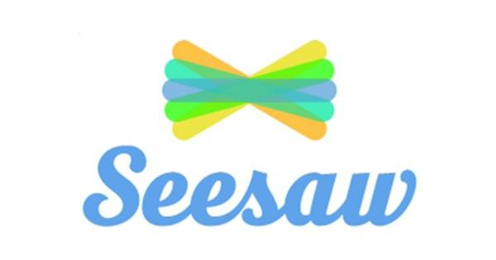
Seesaw
Classroom teachers in Foundation use SeeSaw to provide a glimpse of your child’s learning in the classroom via photos and work samples. Seesaw is also the platform that we used throughout Flexible & Remote Learning in 2020. Please make sure that you have set up Seesaw on your device to ensure that you are not missing any important updates.

Please let us know if you require a new QR code to sign in. Your QR code can be used multiple times, so feel free to sign up any family members that may be interested.

Learning Focus for Term 2
In English, we will continue to learn how to decode texts within the context of reading for meaning. Students will learn comprehension skills of predicting, visualising, making connections and summarising. We will also be building upon our writing by focusing on using one idea to create our own books.

In Maths, we continue to count in a variety of ways, with a particular emphasis on place value. Students will also learn about chance and addition.

In Inquiry & SEL (Social and Emotional Learning), students will continue to explore a range of problem-solving lessons taught through the school wide Respectful Relationships program and will practice a range of self-regulation skills.

Specialist classes
Please be advised of the Term 2 Specialist timetable. Students require a library bag to borrow and must return library books at their next session. Please ensure that appropriate footwear is worn on PE days and you have provided us with an art smock for Visual Arts.

Class | Monday | Tuesday | Wednesday | Thursday | Friday
Foundation  Potts | Library | STEM |  | PE  Visual Arts | Chinese
Foundation  Lisa | Library |  | STEM | PE | Chinese  Visual Arts
Foundation  Amy | Library | STEM | PE | Visual Arts | Chinese
Foundation  Ryan | Library | STEM | Visual Arts | PE | Chinese

In Visual Arts, students will be exploring construction. They will be encouraged to play and investigate construction materials, tools and skills such as joining, shaping and bending, to create a construction artwork.

In STEM, students will continue to work on a range of building activities using a variety of materials. They will concentrate on following directions, the sharing of materials and working together during planned activities. Students will also be making their own plans of things to build out of Lego and other materials and building them.

In Physical Education (PE), students will be focusing on the ball handling skills of bounce, catch and kick. They will also continue to consider the importance of following rules, sharing equipment and space safely during minor team games. Students will participate in a gymnastics unit focusing on locomotion, spring and land and balances.

Upcoming Events
Mother’s Day Stall: Thursday 6th May
Education Week: Monday 24th May to Friday 28th May
Family Fun Afternoon: Thursday 27th May
Last day of Term 2: Friday 25th June
Term 3 begins: Monday 12th July

We look forward to learning together in Term 2.

The Foundation Team,

Edison Potts, Lisa Emin, Amy Butler & Lyndal Ryan

